2.1 Problem 1

Load the auto-mpg sample dataset into the Orange application, and visualize the dataset. Create a scatter plot between mpg and weight - what is the basic relationship between these variables using just visual inspection? Do the results make sense? Why?

**Answer:**

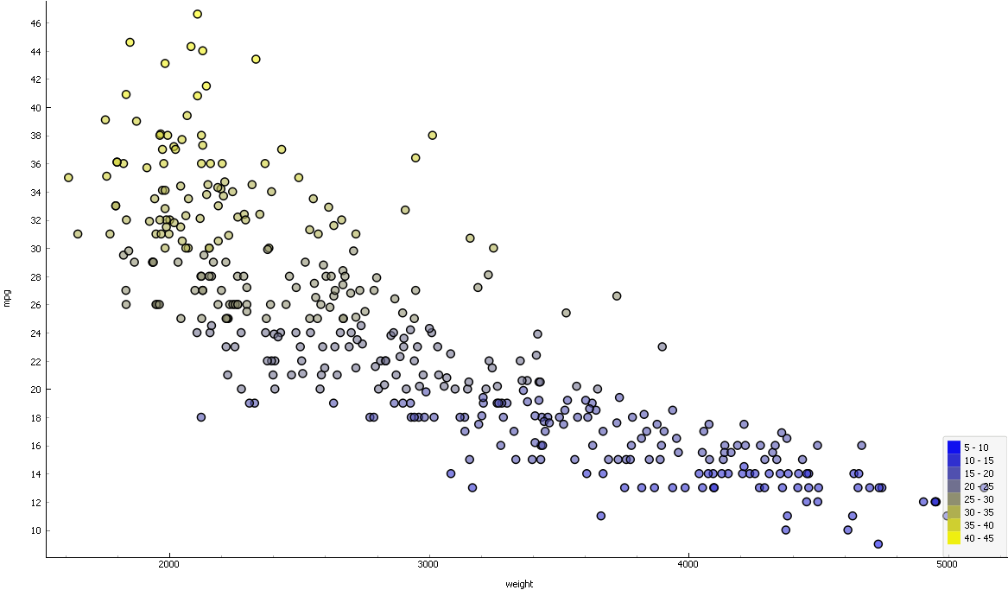

The variables show inverse relation. As the weight of the vehicles increases the mpg decreases. Yes, the results make sense. As the light weighted vehicles can run much faster than the heavy vehicles.